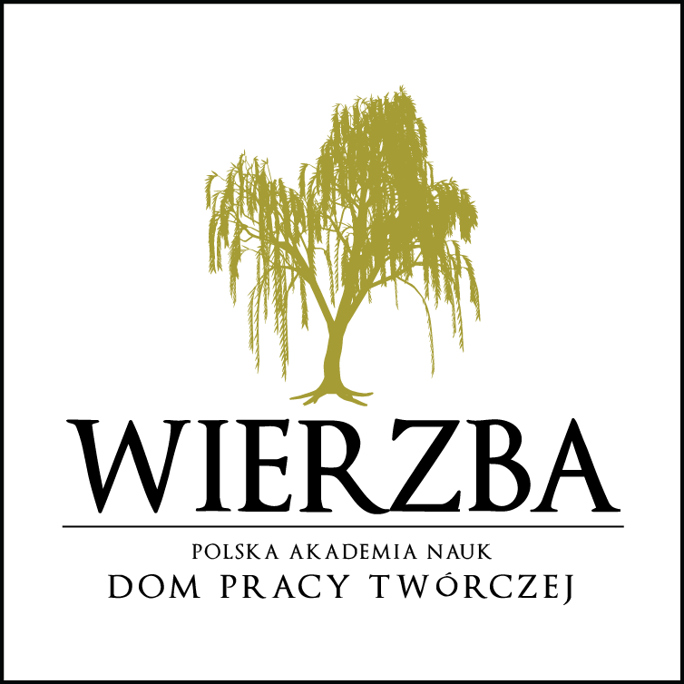
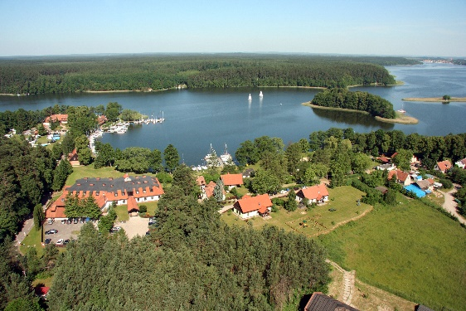
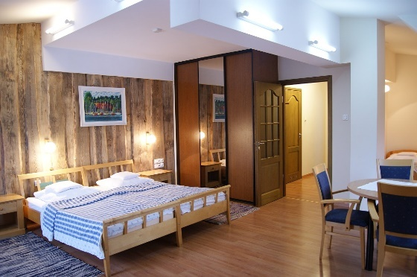

O F
F
E R for employees and retired employees of the Polish Academy of Sciences (PAN) and their families

- Employees and members of PAN - 8% discount
- Pensioners - 15% discount (excluding: 14.06-25.08.2019)

The House of Creative Work “WIERZBA” near Ruciane-Nida wishes to invite all the employees, retired employees and members of the Polish Academy of Sciences (PAN) to our resort in Masuria, in the very heart of the Pisz Forest where the Bełdany, Śniardwy and the Mikołajskie Lake meet.
At the disposal of our Guests, there are rooms of various standard categories, located in a few separate buildings (each room has a bathroom). Please check the website: http://wierzba.pan.pl/ to find out more about the rooms and the price list.
Since the town is located in a very attractive place, there’s quite much going on here in the summer season. Therefore, you should rather choose spring or autumn to visit our Wierzba. Only then can you find true peace and relaxation, only then can you savour the beauty of nature around. Walk along the beautiful forests, try some Nordic Walking, biking in the very heart of the forest… Maybe you’ll even see a wild horse?
Our facility offers you also a mini gym, sauna, billiards and table tennis, table football and a library. For kids, there are a playroom and an outdoor playground.

The complex has its own sailing port where you can rent kayaks, Omega sailing boats (min. Sailor's license required), sailing yachts or motor boats (no license required, after a short training).

At the grill-bar located by the port, we serve you with pizza from a wood-fired oven.

We also invite you to the PANorama Restaurant with the view of the Bełdany Lake. Our restaurant is famous for serving delicious cuisine.
Our chef de cuisine’s specialties include among other things: zander in chanterelle sauce, fish soup, dumplings with pikeperch or meat, and in the season dumplings with berries.

